Western Snowy Plover Excercise - Master

Western Snowy Plover Exercise - Master

Annual Report

Survey Summary

**Inline stats here**

##### Introduction

The western snowy plover (**Charadrius nivosus nivosus**), a small shorebird native to the Pacific coast, has been designated as a threatened species under the Endangered Species Act due to habitat loss, predation, and human disturbance. This species primarily inhabits sandy beaches and coastal dunes, where it nests in the intertidal zone and feeds on invertebrates. Characterized by its cryptic plumage, the western snowy plover is particularly vulnerable during the breeding season, which typically occurs from March to September. Observations conducted by the U.S. Fish and Wildlife Service along select beaches in the Pacific Northwest have provided critical data on population dynamics, nesting success, and habitat utilization, contributing to the understanding of the species’ ecological needs and challenges.

##### Methods

comprehensive information on the breeding and migratory populations of western snowy plovers at the survey sites. During the summer months, surveys focused on identifying nesting sites and assessing breeding success, while winter surveys aimed to document the abundance and distribution of migratory plovers that utilize these coastal environments.

Test

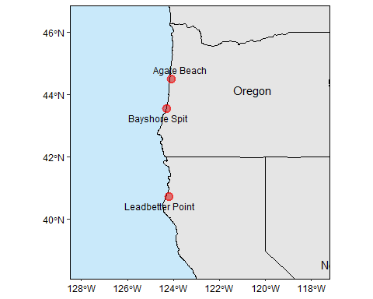

Figure 1. Map of Western Snowy Plover survey locations along the coastline.

##### Results

The data on Western Snowy Plover total counts indicate notable seasonal and site-specific trends. In the summer, Leadbetter Point had the highest population, with a total count of 85 individuals, followed by Agate Beach with 56, while Bayshore Spit had the lowest at 24 (table 1). This suggests that Leadbetter Point and Agate Beach are critical breeding areas. In contrast, winter counts showed a significant decline across all sites, with Agate Beach recording 25 plovers, Leadbetter Point 21, and Bayshore Spit 19. The decrease in overall counts during the winter season, especially the absence of juveniles, highlights the migratory behavior of the plovers and underscores the importance of these habitats for both breeding and wintering populations.

Furthermore, observational plover counts per hour reveal significant seasonal trends across the sites. In the summer, Leadbetter Point had the highest observation rate at 10.97 plovers per hour, indicating a robust presence during the breeding season, followed closely by Agate Beach with 8.3 observations per hour (figure 2). Bayshore Spit had the lowest summer observation rate at 3.0, suggesting it is less frequented by plovers during this time. Conversely, winter counts showed a marked reduction in observational rates across all sites, with Agate Beach recording 3.33 observations per hour, Leadbetter Point at 2.9, and Bayshore Spit at 2.05. This decline underscores the migratory patterns and decreased visibility of the plovers during the non-breeding season, highlighting the importance of seasonal monitoring to understand the dynamics of plover populations in these habitats.

|  |  |  |  |  |  |
| --- | --- | --- | --- | --- | --- |
| Survey Season | Site | Total Males | Total Females | Total Juveniles | Total Count |
| summer | Agate Beach | 24 | 22 | 10 | 56 |
| winter | Agate Beach | 9 | 4 | 12 | 25 |
| summer | Bayshore Spit | 3 | 17 | 4 | 24 |
| winter | Bayshore Spit | 5 | 13 | 1 | 19 |
| summer | Leadbetter Point | 31 | 31 | 23 | 85 |
| winter | Leadbetter Point | 8 | 9 | 4 | 21 |

Table 1. Seasonal Western Snowy Plover observational counts by survey site.

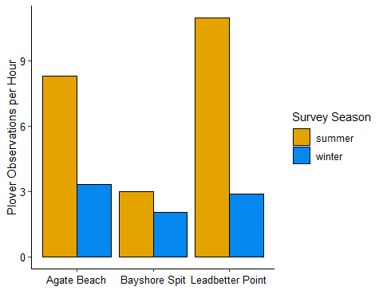

Figure 2. Text.

##### Discussion

The results from the observational and total count data of Western Snowy Plovers indicate significant seasonal and site-specific trends that are crucial for understanding the species’ population dynamics. The higher summer counts and observational rates at Leadbetter Point and Agate Beach suggest these locations are vital breeding habitats, supporting robust populations during the nesting season. The substantial presence of juveniles at these sites further emphasizes their importance for reproductive success. Conversely, the notable decline in both total counts and hourly observations during the winter months across all sites highlights the migratory nature of the plovers and their reduced visibility during this period. Such seasonal variations in abundance and behavior reinforce the need for targeted conservation efforts during critical breeding times, as well as continued monitoring throughout the year to address the challenges posed by habitat loss and human disturbances. These findings underscore the importance of maintaining and enhancing habitat quality at key sites to support the long-term survival of the western snowy plover in the Pacific Northwest.

|  |  |
| --- | --- |
|  |  |
|  |  |

|  |  |
| --- | --- |
|  |  |
|  |  |